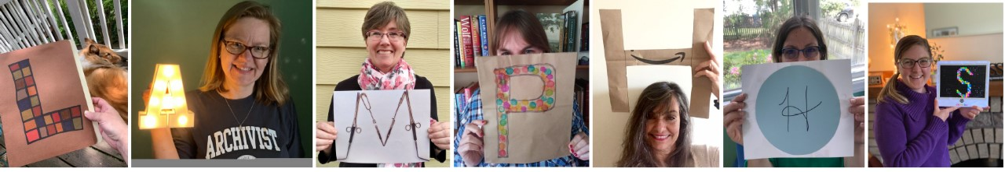

CALL FOR LAMPHHS TRAVEL SCHOLARSHIP APPLICATIONS

The Travel Scholarships Committee of Librarians, Archivists, and Museum Professionals in the History of the Health Sciences (LAMPHHS) is now accepting applications from those seeking funds to support their attendance at the 2022 Annual Meeting in Saratoga Springs, New York on April 20-21. LAMPHHS awards up to four annual conference travel stipends to members of the organization who are staff, volunteers, students, or early career professionals working for health science history museums, libraries, or archives. The purpose of these awards is to encourage and support continued education and professional engagement for those working in the field.

The Awards are:

Patsy Gerstner Travel Fund ($600.00)
Gretchen Worden Memorial Travel Fund ($600.00)
Joan E. Klein Travel Scholarship (two $600.00 awards)

Priority for the awards will be given to students and early career professionals, with additional weight given for those with no other funding available. Award checks will be presented at the conference business meeting. If you need funding up front to make travel arrangements to the conference, please do include that information in your personal statement so that arrangements can be made.

IMPORTANT INFORMATION:
- These awards are open to students who are degree-seeking individuals attending an accredited college or university, and to staff, volunteers or early career professionals working in the history of the health sciences, particularly, in libraries, archives, or museums. Early career professionals are those who have worked in the history of the health sciences field fewer than five years, although they may have been employed in the profession longer.
- Applicants should submit a brief personal statement (no more than 500 words) which highlights their interest in the conference, how attendance will benefit them, and why they need financial support.
- Applicants should submit along with their application a letter of recommendation from either their academic advisor (students) or immediate supervisor (staff and volunteers). These letters should be sent by the applicant with the application. Incomplete applications will not be considered.
- Applications must be received 8 weeks before the opening session of the conference. The deadline for the 2022 Annual Meeting is 20 February 2022. Late applications will not be considered.
- All applicants will be notified of the scholarship committee decision 6 weeks prior to the start of the conference. This notification deadline is 8 March 2022.
- Previous winners are not eligible to apply.
- The Travel Scholarships Committee reserves the right to not award all travel stipends in any particular year.

APPLICATION FOR LAMPHHS TRAVEL SCHOLARSHIPS

Name:
Mailing Address:
Telephone:
Email:
City:
State:
Zip:

Are you a first-time attendee to the LAMPHHS annual meeting? YES NO

Do you have any other sources of outside funding available to attend this meeting? YES NO

Applicant status (select one): STUDENT / EARLY CAREER PROFESSIONAL / VOLUNTEER / STAFF

FOR STUDENTS:
Institution:
Advisor:

Degree sought:
Proposed graduation date:

FOR EARLY CAREER PROFESSIONALS, VOLUNTEERS, STAFF:
Employer:
Supervisor:

Job Title:
Start Date (M/Y):

Your signature on this application indicates that the above information is correct:

Signature Date

Please submit this application, your personal statement, and letter of recommendation to the committee chair, Stephen Greenberg, by email to:

patzere4@gmail.com

If you are unable to return the completed application by email, please contact Stephen Greenberg to get a USPS letterpost (snailmail) address.

